**Pass task 6.1: Battleship sprint**

**Meeting Agenda**

Date/Location: 11-April-2019 at 2:00PM in A302

**Information Updates/Reminders**

* Last week was about converting and documenting the code
* This week we will use a sprint process over two weeks to fix bugs and extend the project. (No bug fixing or extensions yet!)
* Help from an external consultant has been provided to help get the code converted and working if that was not done.
* Everyone should have used toggl.com to track their time last week. Also track time on tasks this week with Toggl.
* Tutor must be added to GitHub, Trello and Toggl.
* Slack will be used to show the changes in the Trello board during the sprint of activity
* The Programming Help Desk ATC620 is *still* available to help us with programming for this unit.

**Decisions Needed**

* Action(s) created to fix missing code documentation (Should not be one person – break into smaller tasks the team can share)
* Action(s) created to confirm converted code works the same as the pre-conversion code (simple functional side-by-side equivalence testing).
* Action(s) to improve the documented list of identified feature issues (Missing, bugs or possible extensions categories)
* Solving the known bugs
* Fix the functionality issues
* Add in extension ideas

**General Items**

* The Trello board needs to be updated ready for the planned Sprint process. In particular columns for project backlog and sprint backlog will be needed.
* Create and link the team slack so that we can be notified and have a nice record of the Trello updates.
* The project backlog of tasks needs to be created. Use the existing bugs and features we have documented, and convert to the required format. Need a meeting after this meeting to get that done and into Trello (today).
* Project backlog tasks need to be prioritised and their time estimated using 1,2,4,8 hour categories. (Today)
* The new Sprint backlog needs to be pre-selected ready for discussion and approval with the project owner. (Today)
* Once Sprint has started, hold a daily scrum meeting. (Start next week?)
* Still need to make then SwinGameSDK to work as the program could not run without it.
* Game bugs that exist from the previous week still need fixing as the program could not run
* Game functionality that is missing or not working from the previous week still need fixing as the program could not run

**Meeting Minutes**

Date/Location: 11/4/19 at Swinburne University of Technology in A302

Attendees: Marc Chai, Lim Jia Lok, Aldalton Choo

Start Time: [2:30 p.m.]

End Time: [3:30 p.m.]

**Decisions**

* AC will be fixing the buttons disappearing and making the arrow button point in the correct direction
* LL will be fixing the board being out of bounds and coordinates not labelled correctly.
* MC will do the fixing of the board not functioning properly when clicking on a specific grid.
* LL will add in an extension for the UI portion of the battleship program by adding new sound for the AI, different colour for the AI, and also a reset button in the playing interface to clear the board.
* LL will add in an extension for the score board in the playing interface to show the players' score.
* AC will add in an extension to have an easy mode as the current game logically only has two modes which is medium and hard.
* MC will add in an extension to have an undo button to redo one move in the playing interface.

**Actions**

* 15-4-19 AC should be done with fixing the buttons disappearing and making the arrow button point in the correct direction
* 15-4-19 LL should be done with fixing the board being out of bounds and coordinates not labelled correctly.
* 15-4-19 MC should be done with fixing the board not functioning properly when clicking on a specific grid.
* 20-4-19 LL should be done adding the new sound and colour for the AI and also a reset button to clear the board
* 20-4-19 LL should be done adding in the scoreboard
* 20-4-19 AC should be done adding in easy mode for the game
* 20-4-19 MC should be done adding in an undo button

**Scrum meeting**

Scrum meeting 15th of April 2019



Figure (1) Scrum meeting 1 on the 15th of April 2019



Figure (2) Scrum meeting 1 on the 15th of April 2019

Scrum meeting 16th of April 2019

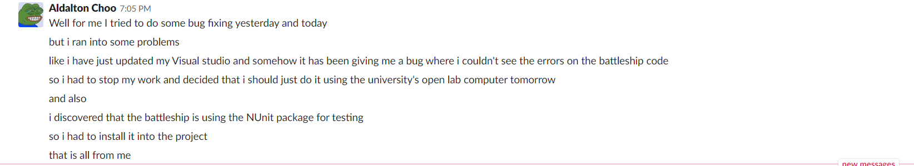

Figure (3) Scrum meeting 2 on the 16th of April 2019

Scrum meeting 17th of April 2019



Figure (4) Scrum meeting 3 on the 17th of April 2019

Bug fixes done on the 17th of April 2019:

The bug fixes that I’ve done are too tedious, so I will give a few examples of what I did. In figure 5, HumanPlayer is an object belonging to the class GameController but since it is being called in the DeploymentController class so it currently doesn’t exist in the context of the DeploymentController class, I had to call the GameController class inside the DeploymentController class so that the IDE understands where I am trying to call the HumanPlayer object from.



Figure (5) Bug fixing in DeploymentController.cs

Another example of the bug fixes that I have done is the battleship deploying a few squares above the square box that you have clicked on to deploy the ship. In figure 6 you can see that the line of code with mouse.y is missing a direction and this is what caused the battleship to deploy a few squares above. So in order to fix this problem, I just added a .FIELD_TOP to beside the mouse.Y and this fixed the bug.



Figure (6) Fix bug in deployment of ship appearing a few squares above the square box that was clicked to deploy the ship.

Scrum meeting 18th of April 2019



Figure (7) Scrum meeting 4 on the 18th of April 2019



Figure (8) Scrum meeting 5 on the 19th of April 2019



Figure (9) Scrum meeting 6 on the 20th of April 2019

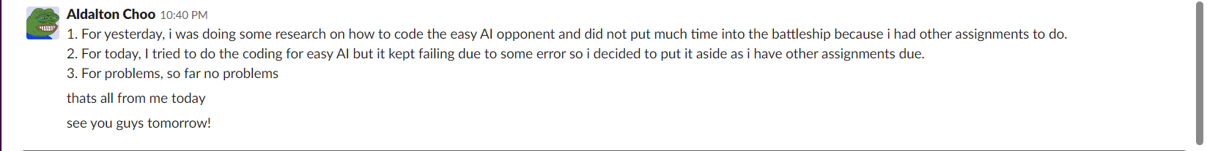

Figure (10) Scrum meeting 7 on the 21st of April 2019



Figure (11) Scrum meeting 8 on the 22nd of April 2019

Implementing easy AI mode and fixing the bug where the battleship cannot deploy in a vertical position on the 22nd of April 2019:

For me to implement the easy AI mode, I had to create a new class for the easy ai and to do this I used the medium AI class as a template and edit accordingly to make the AI easier. In figure 12, I edited the ProcessShot method for the easy AI class so that the AI will only be able to attack either in an upwards direction or a left direction. When doing this, I noticed that the default AI difficulty was set to hard to I changed it to easy by default.

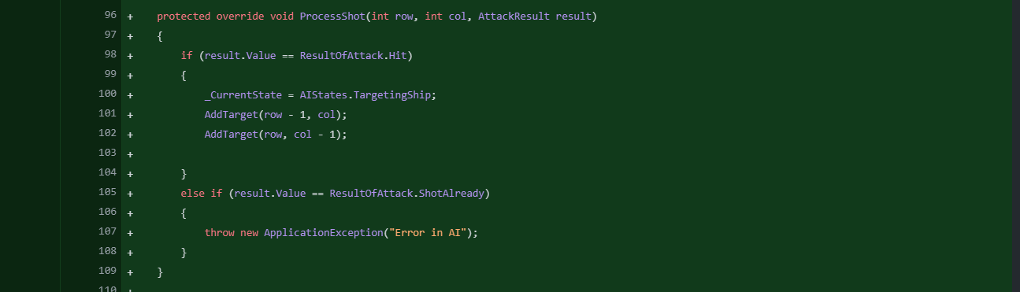

Figure (12) Example of easy AI mode

Other than that, I have also fixed the bug where you were not able to deploy the ship in a vertical position before by changing the direction from LeftRight to UpDown as shown in figure 13.



Figure (13) Bug fix of ship not able to deploy in vertical position



Figure (14) Scrum meeting 9 on the 23nd of April 2019

Trello board:

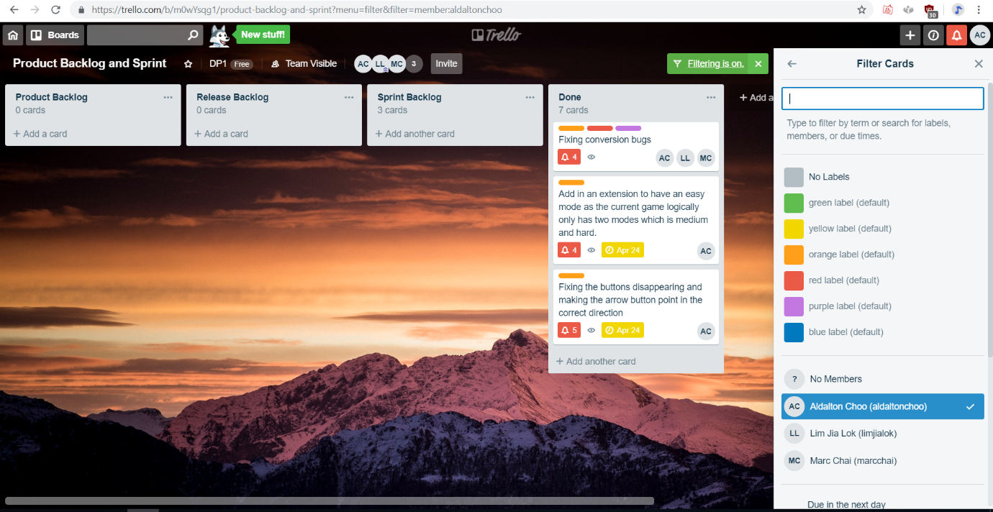

Figure (15) Trello board for Aldalton Choo

Toggl report:

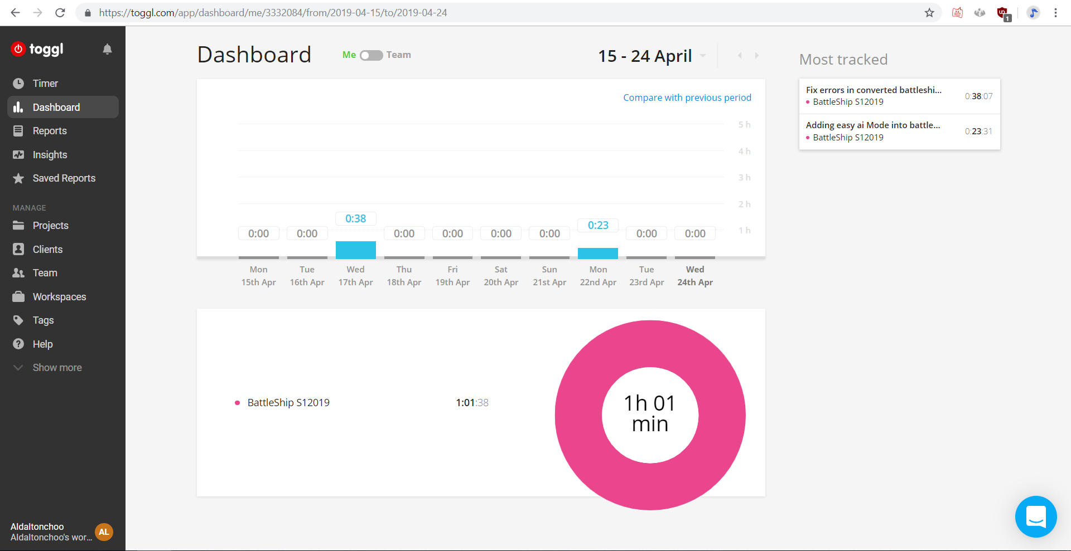

Figure (16) Toggl graph for Aldalton Choo

Git hub contribution and network graph:

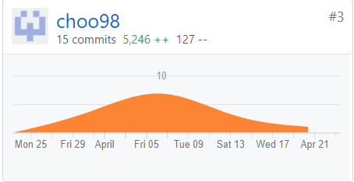

Figure (17) git hub contribution graph for Aldalton Choo

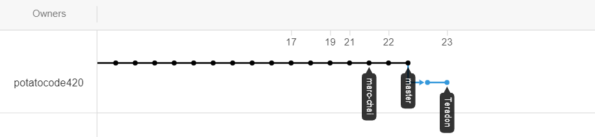

Figure (18) git hub network graph for Aldalton Choo